1: Find number of occurrence and index of that desired string.

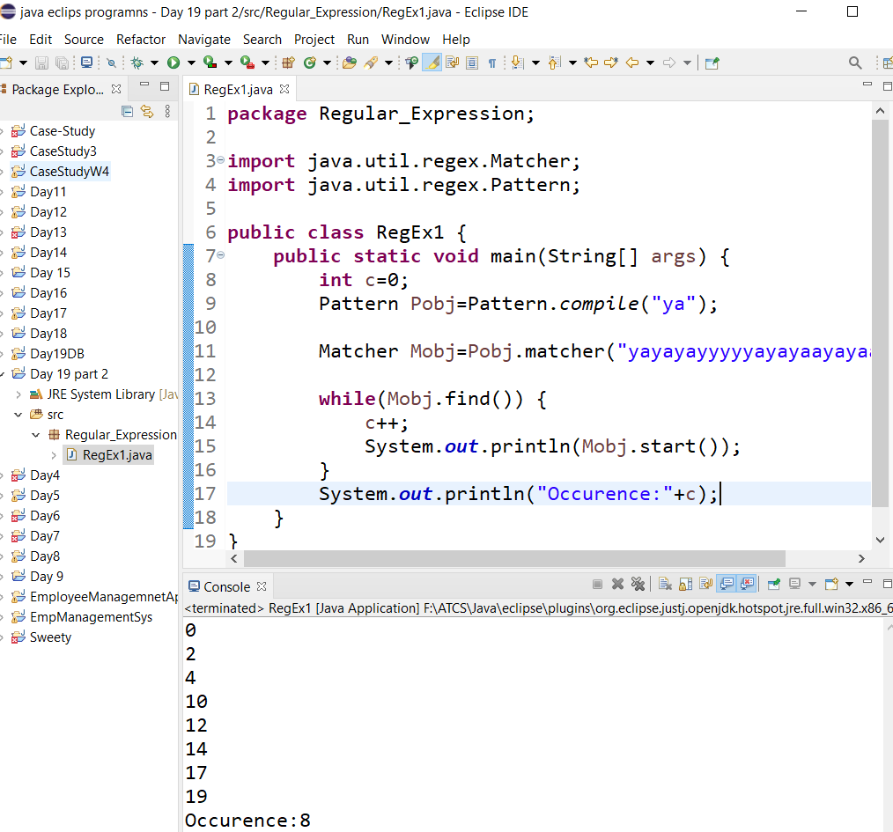

2. Find space in String

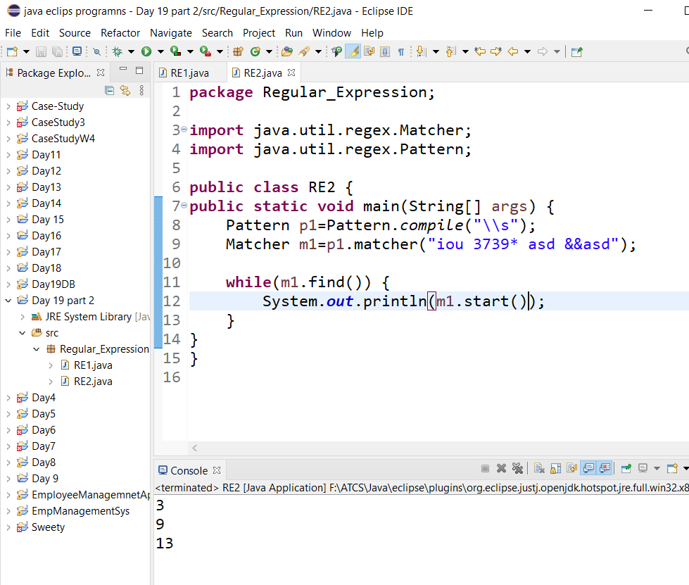

3. Split in pattern

4 date

5. Time

